Biruni University
Assignment Submission Guide
For Students

Step 1: a) Enter our university’s BirDeha system by clicking on https://bem.biruni.edu.tr/
b) Click on the (Log In) link in the upper right corner of the first screen.
Step 2: Log in to the system with your e-mail address starting with your student number and enter your password.
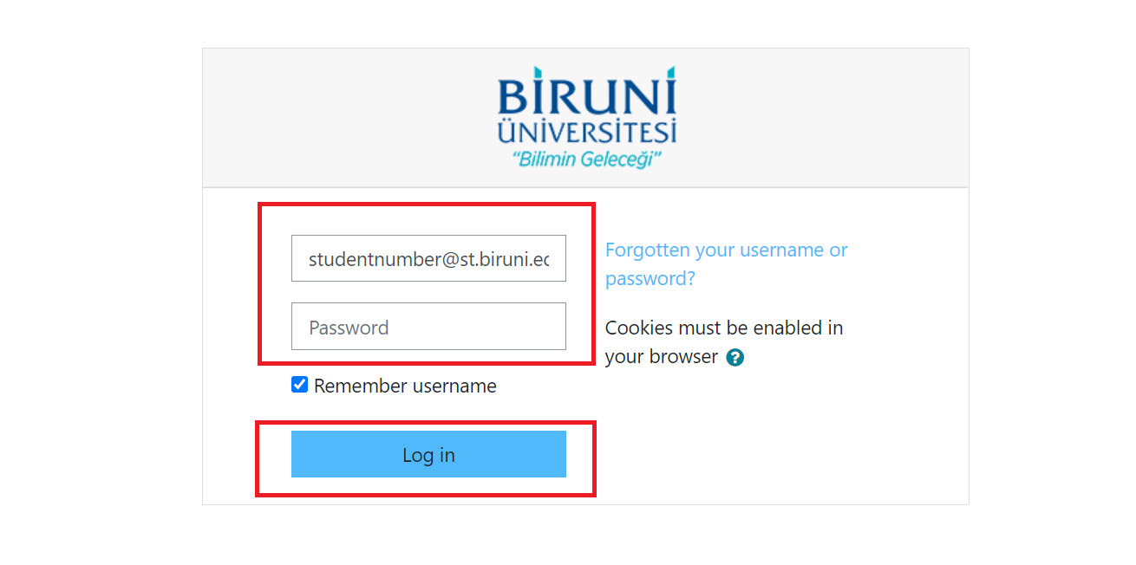

Step 3: In the list in the “Timeline” section, you will see the link and details about the course for which the assignment was created.
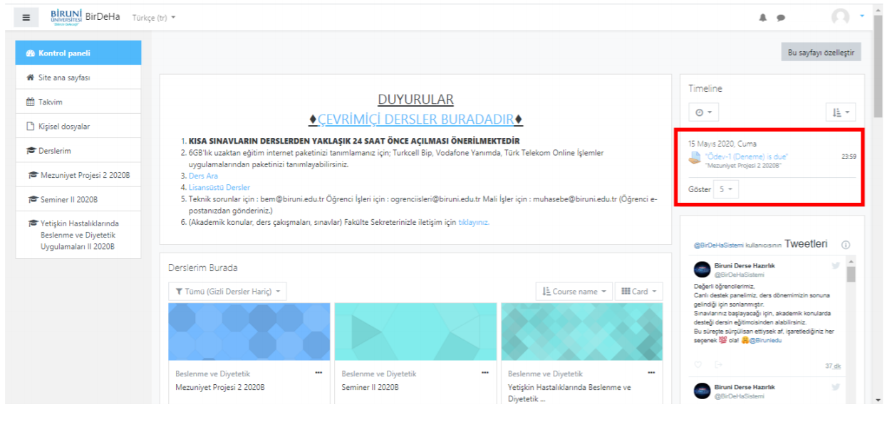

Step 4: Click “Add submission” when the submission time starts.
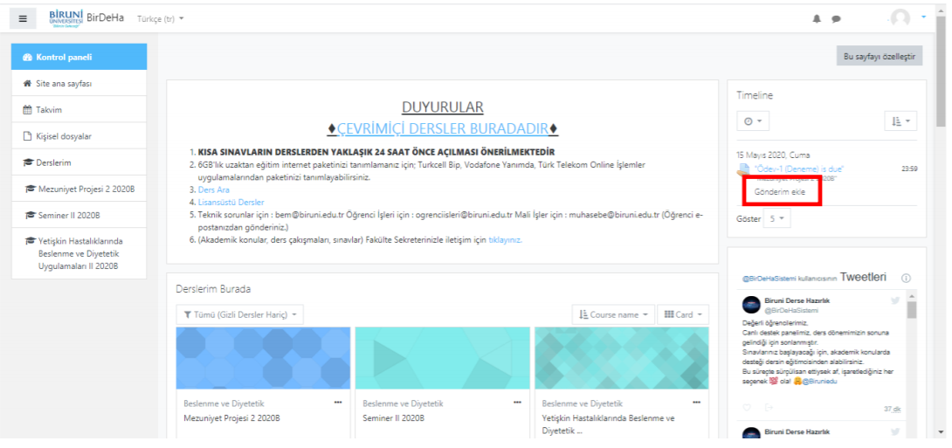

Step 5: You will see the details of the assignment and the page where you can submit your assignment.
In the field below, you can drag/drop your assignment file or click on the blue down arrow and choose from your computer and start the submission process.
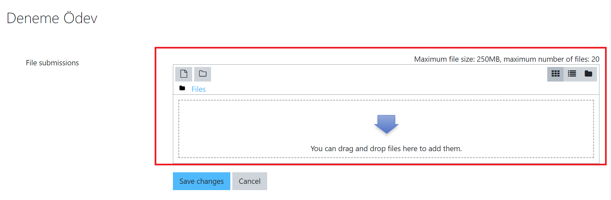
Step 6: After you are sure of the file you want to submit, click the “Save Changes” button.
If you think it is the wrong file, click the “Cancel” button and repeat the process.
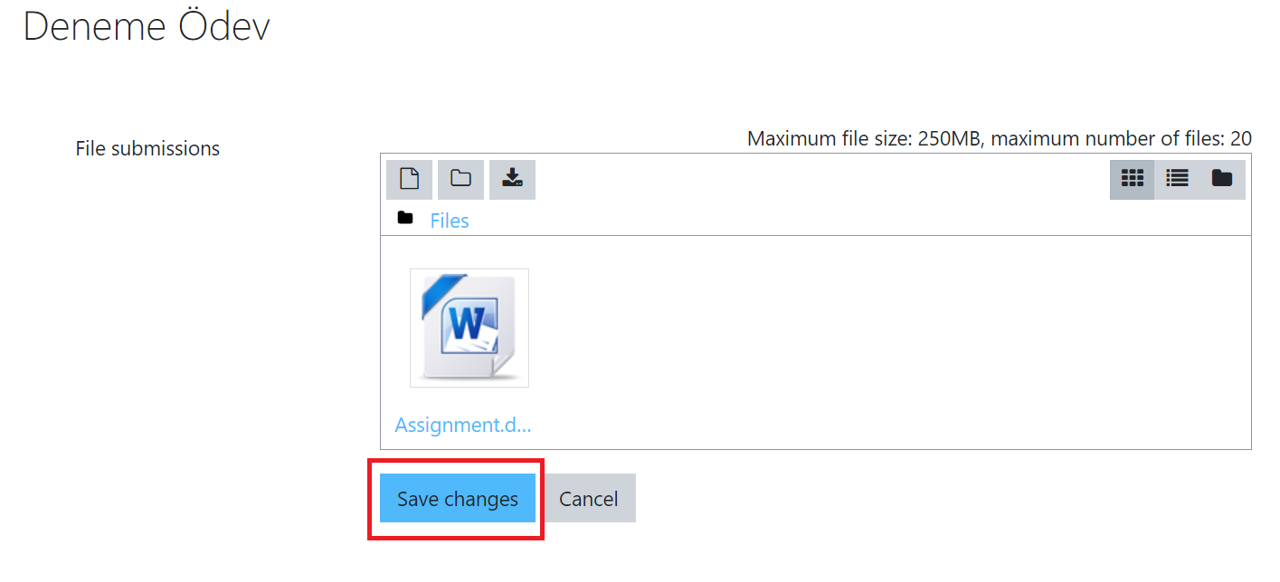

Step 7: After clicking “Save Changes”, you will see the Submission Status Page.
If you think there is a problem, click the “Edit Submission” button.
If you want to cancel the submission completely, click the “Remove Submission” button.
Note: You can return to Step 5 by clicking “Edit Submission”
